

**Wasabi Resignation Form**

**Branch**: 173 Wardour St

**Date**: 16/08/2019

Dear Cesar,

Thank you very much for the opportunity you’ve given me to learn all about store management and proper customer service. I have genuinely enjoyed my time with the company, and I believe the experience has taught me much about the hospitality industry as well as how to effectively manage employees.

Please accept this as formal notice of my resignation from the position of Branch Manager. My last day of work will be 16/09/2019

In the meantime, I will be happy to assist in the transition of a new Manager and I will do my best to hand off my current assignments and outstanding work prior to 16/09/2019.

Yours sincerely,

Federico Biglia

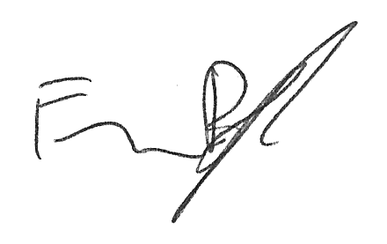

………………………………………………………………………………………………………………………………………………………….

FOR WASABI USE ONLY

Return item check list for leaver:

|  |  |  |  |  |  |  |  |
| --- | --- | --- | --- | --- | --- | --- | --- |
| Item | Issue date | Issued by | Date of return | Return to | Condition  (good,damage, loss,reimburse) | Checked by | Confirmed by |
|  |  |  |  |  |  |  |  |
|  |  |  |  |  |  |  |  |
|  |  |  |  |  |  |  |  |
|  |  |  |  |  |  |  |  |
|  |  |  |  |  |  |  |  |
|  |  |  |  |  |  |  |  |

Record by: _________________________